DAY-3
1: Bell–LaPadula Access Control Simulator
# Bell-LaPadula Simulator

levels = {
"Unclassified": 0,
"Confidential": 1,
"Secret": 2,
"TopSecret": 3
}

print("Security Levels:")
for k in levels:
print(k)

subject = input("Enter Subject Level: ")
object_ = input("Enter Object Level: ")
operation = input("Enter Operation (read/write): ").lower()

if subject not in levels or object_ not in levels:
print("Invalid security level!")
else:
s_level = levels[subject]
o_level = levels[object_]

if operation == "read":
if s_level >= o_level:
print("ACCESS GRANTED (No Read Up satisfied)")
else:
print("ACCESS DENIED (No Read Up violated)")
elif operation == "write":
if s_level <= o_level:
print("ACCESS GRANTED (No Write Down satisfied)")
else:
print("ACCESS DENIED (No Write Down violated)")
else:
print("Invalid operation!")
OUTPUT:
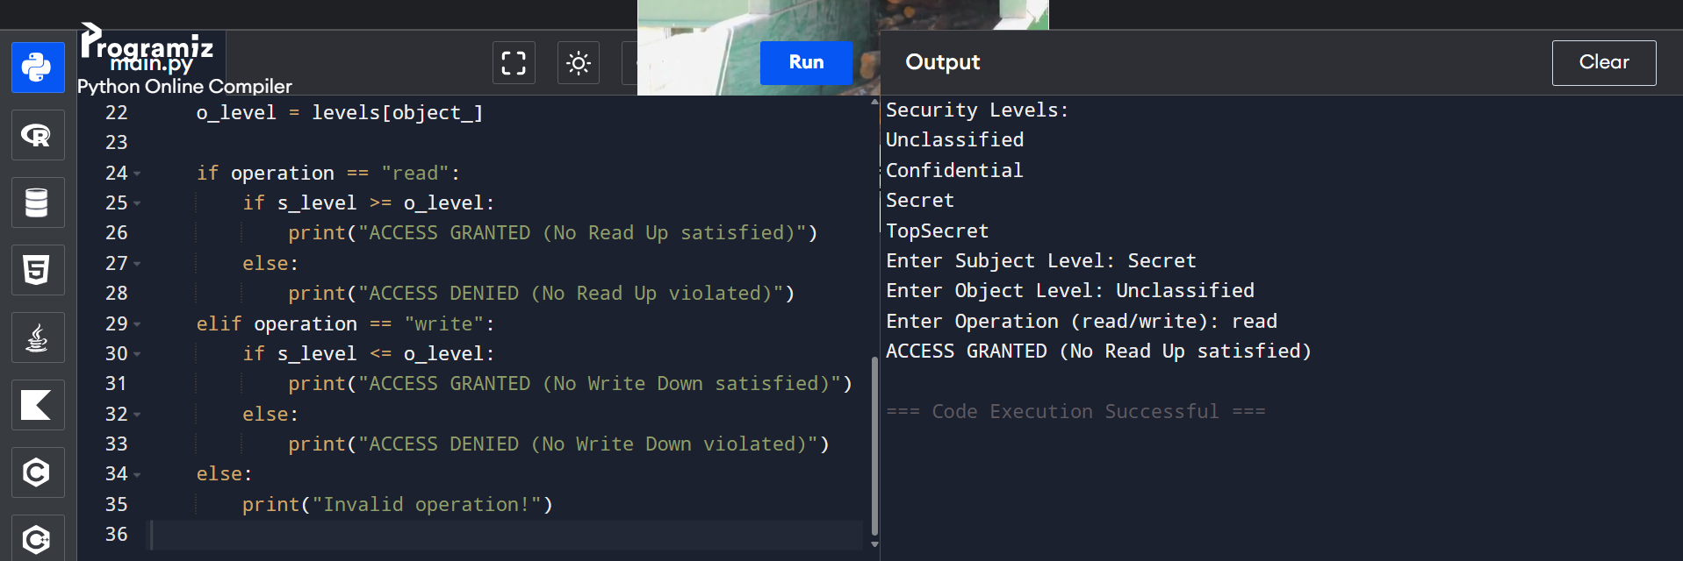
2: Passive vs Active Attack Detection
# Passive vs Active Attack Classification

passive_attacks = ["packet sniffing", "traffic analysis", "eavesdropping"]
active_attacks = ["replay attack", "message modification", "masquerade", "dos"]

attack = input("Enter attack type: ").lower()

if attack in passive_attacks:
print("Attack Type: Passive Attack")
print("Affected Security Goal: Confidentiality")
elif attack in active_attacks:
print("Attack Type: Active Attack")
if attack == "dos":
print("Affected Security Goal: Availability")
else:
print("Affected Security Goal: Integrity")
else:
print("Unknown attack type")
OUTPUT:
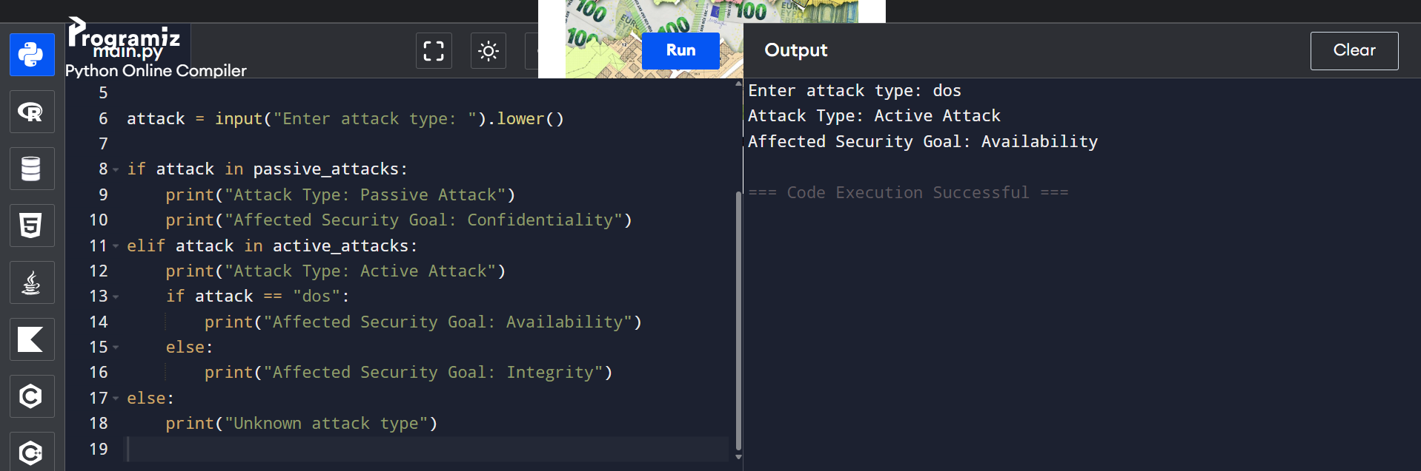
3: CIA Security Goal Analyzer
# CIA Security Goal Analyzer

print("Select Scenario:")
print("1. Data tampering")
print("2. Server outage")
print("3. Password leak")

choice = int(input("Enter choice (1-3): "))

if choice == 1:
print("Violated Goal: Integrity")
print("Suggested Protection: Hashing / Digital Signature")
elif choice == 2:
print("Violated Goal: Availability")
print("Suggested Protection: Backup Server / Load Balancer")
elif choice == 3:
print("Violated Goal: Confidentiality")
print("Suggested Protection: Encryption / Strong Authentication")
else:
print("Invalid choice"):

OUTPUT
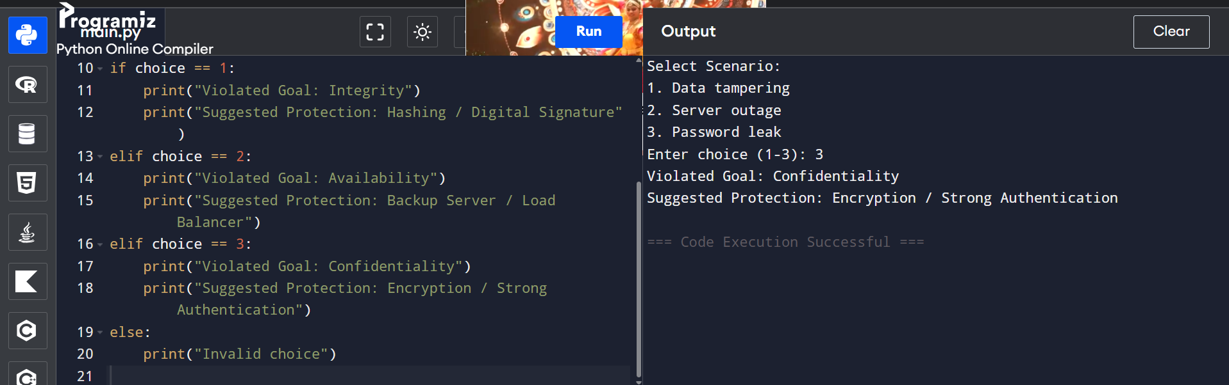
4: Risk Assessment Calculator
# Risk Assessment Calculator

threat = input("Enter Threat Name: ")
probability = int(input("Enter Probability (1-10): "))
impact = int(input("Enter Impact (1-10): "))

risk = probability * impact

print("Risk Score:", risk)

if risk <= 20:
print("Risk Level: LOW")
print("Recommended Control: Monitor regularly")
elif risk <= 60:
print("Risk Level: MEDIUM")
print("Recommended Control: Implement security controls")
else:
print("Risk Level: HIGH")
print("Recommended Control: Immediate mitigation required")

OUTPUT:
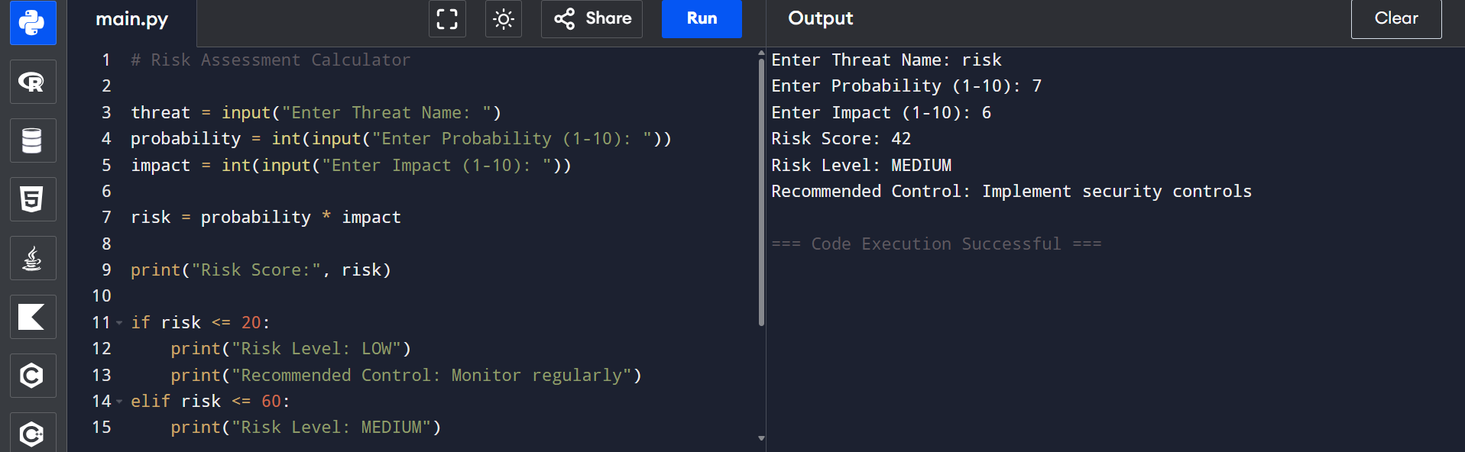
5: Access Control List (ACL) Simulation
# ACL Simulation with Bell-LaPadula rule display

users = {
"Alice": ["read", "write"],
"Bob": ["read"],
"Charlie": []
}

username = input("Enter Username: ")
operation = input("Enter Operation (read/write): ").lower()

if username in users:
if operation in users[username]:
print("ACCESS GRANTED")
if operation == "read":
print("Bell-LaPadula Rule Applied: No Read Up")
else:
print("Bell-LaPadula Rule Applied: No Write Down")
else:
print("ACCESS DENIED")
else:
print("User not found")

OUTPUT:
